**MEDLINE Search Strategy**

# MEDLINE Search Strategy

*Ovid MEDLINE(R) Epub Ahead of Print, In-Process & Other Non-Indexed Citations, Ovid MEDLINE(R) Daily and Ovid MEDLINE(R)*

1. Retinopathy of Prematurity/

2. exp Ophthalmoscopy/

3. retinopath*.tw.

4. retrolental fibroplasia?.tw.

5. ophthalmoscop*.tw.

6. (scleral adj (depress* or indent*)).tw.

7. 1 or 2 or 3 or 4 or 5 or 6

8. exp Infant, Newborn/

9. ((prematur* or pre-matur* or preterm* or pre-term*) adj2 (infant* or newborn? or baby or babies or neonat* or neo-nat* or child*)).tw.

10. (premie? or preemie?).tw.

11. (low adj2 (birthweight? or birth weight?)).tw.

12. (small adj2 gestation* age).tw.

13. 8 or 9 or 10 or 11 or 12

14. exp Pain/

15. Pain Management/

16. Pain Measurement/

17. exp Analgesia/

18. exp Analgesics/

19. Anesthetics, Local/

20. pain*.tw.

21. analgesia.tw.

22. analgesic?.tw.

23. (local* adj2 anesthetic?).tw.

24. comfort*.tw.

25. discomfort*.tw.

26. stress*.tw.

27. sooth*.tw.

28. (pacify* or pacifie*).tw.

29. 14 or 15 or 16 or 17 or 18 or 19 or 20 or 21 or 22 or 23 or 24 or 25 or 26 or 27 or 28

30. 7 and 13 and 29

|  |  |  |
| --- | --- | --- |
| **Supplementary table 1.** Intervention lumping | | |
| **Intervention** | **Group** | **Rationale/Description** |
| *No anesthetic eye drops* |  |  |
| Non-nutritive sucking | Physical | Mechanism of action through distraction |
| Placebo | Placebo | - |
| Sweet taste alone | Sweet taste alone | Sucrose and glucose combined, similar mechanism |
| Repeated sweet taste |  |  |
| sweet.sing |  | sweet sing |
| *Anesthetic eye drops* | | |
| Alone | Eye drops alone | - |
| No speculum | Eye drops + no speculum | Speculum thought to be major painful component of intervention |
| Sweet taste | Eye drops + sweet | Sucrose + glucose combined, similar mechanism |
| WFDRI | Eye drops + WFDRI | Camera does not require scleral depression and can be done more rapidly |
| Feeding one hour prior | Eye drops + diet one hour | Infants fed one hour before procedure |
| Feeding two hours prior | Eye drops + diet two hours | Infants fed two hours before procedure |
| Non-nutritive sucking | Eye drops + physical | Mechanism of action through distraction |
| Sweet + nitrous oxide | Eye drops + sweet + N2O | Sweet taste combined with additional pharmacological intervention |
| Acetaminophen 30 minutes prior to procedure | Eye drops + acetaminophen 30 minutes | Time of onset of acetaminophen in neonates approximately 60 minutes |
| Acetaminophen 60 minutes prior to procedure | Eye drops + acetaminophen 60 minutes |
| Sensorial saturation | Eye drops + sweet multisensory | Combines sweet taste, non-nutritive sucking, swaddling, touch, voice, and familiar odour |
| NIDCAP | Eye drops + sweet multisensory | Combines sweet taste, non-nutritive sucking, swaddling, touch, and voice |
| Cup-fed expressed breast milk | Eye drops + ebm multisensory | Cup feeding provides olfactory and gustatory stimulation |
| Expressed breast milk + non-nutritive sucking | Eye drops + ebm multisensory | Combines gustatory and physical stimulation |

|  |  |  |  |  |  |  |  |
| --- | --- | --- | --- | --- | --- | --- | --- |
| **Supplementary table 2.** Characteristics of studies | | | | | | | |
| Author and year | Design | Method | Speculum | Scleral depression | PMA (mean) | BW (mean) | Treatments |
| Boyle 2006 | Parallel | BIO | yes | yes | 34.9 | 1132.8 | TA vs TA + Sweet taste vs NNS + TA vs Sweet taste multisensory + TA |
| Cogen 2011 | Parallel | BIO | yes | yes | 34 | 924 | No treatment vs TA |
| Costa 2013 | Parallel | BIO | yes | yes | 35.2 | 1260.9 | TA vs TA + Sweet taste |
| Dhaliwal 2010 | Crossover | WFDRI | yes | no | 34.1 | 1208 | TA vs WFDRI + TA |
| Dilli 2014 | Parallel | BIO | yes | unclear | 35.4 | 1304 | TA + NNS vs Sweet taste multisensory + TA |
| Gal 2005 | Crossover | BIO | yes | yes | 33.3 | NA | TA vs TA + Sweet taste |
| Grabska 2005 | Parallel | BIO | yes | yes | 35.3 | 1880 | TA + NNS vs Sweet taste multisensory + TA |
| Kabatas 2016 | Parallel | BIO | yes | unclear | 32.4 | 1130.3 | TA vs Acetaminophen + TA |
| Kleberg 2008 | Crossover | BIO or WFDRI | yes | yes in London | NA | NA | TA vs Sweet taste multisensory + TA |
| Mandel 2012 | Parallel | BIO | yes | yes | 35.2 | 1025.4 | TA + Sweet taste vs NO + Sweet taste + TA |
| Marsh 2005 | Crossover | BIO | yes | yes | 33 | NA | No treatment vs TA |
| Mehta 2010 | Crossover | BIO | yes | yes | NA | NA | NNS vs NNS + TA |
| Mitchell 2004 | Parallel | BIO | yes | yes | 35.2 | 976 | TA + NNS vs Sweet taste multisensory + TA |
| Nesargi 2015 | Parallel | BIO | yes | yes | 34.3 | 1167 | TA vs Sweet taste |
| Olsson 2011 | Parallel | BIO | no | unclear | NA | 1126.5 | TA vs TA + Sweet taste |
| O'sullivan 2010 | Parallel | BIO | yes | yes | 33.1 | 1140 | TA + NNS vs Sweet taste multisensory + TA |
| Rosali 2015 | Parallel | BIO | yes | yes | 34.6 | 1356 | TA vs ebm + TA |
| Rush 2005 | Parallel | BIO | yes | unclear | NA | 1185.3 | TA vs Sweet taste multisensory + TA |
| Saunders 1993 | Parallel | BIO | yes | yes | 36 | 1093 | No treatment vs TA |
| Strube 2010 | Parallel | BIO | yes | yes | 35.8 | 1091.7 | 1hr + feed vs 2hr + feed |
| Manjunatha 2009 | Parallel | BIO | yes | yes | NA | NA | TA vs morphine + TA vs Acetaminophen + TA |
| Seifi 2013 | Parallel | BIO | yes | yes | NA | 987.1 | TA vs TA + Sweet taste vs Acetaminophen + TA |
| Zeraati 2016 | Parallel | unclear | unclear | unclear | 35.5 | 1370.8 | TA vs sensorial + saturation |
| SenerTaplak 2017 | Parallel | BIO | yes | yes | NA | NA | TA + NNS vs EBM multisensory + TA vs Sweet taste multisensory + TA |
| Benzer 2015 | Parallel | unclear | unclear | unclear | NA | NA | No treatment vs Sweet taste + rep vs Sweet taste + single |
| Ilarslan 2012 | Parallel | unclear | yes | unclear | NA | NA | TA + NNS vs NNS + TA + Sweet taste |
| Mehta 2005 | Crossover | bio and wfdri | yes | no | NA | NA | TA + Speculum vs TA – Speculum vs TA + WFDRI |
| Ucar 2014 | Parallel | unclear | unclear | unclear | 34.2 | 1280 | TA + NNS vs TA + Sweet taste vs Sweet taste multisensory + TA |
| Xin 2016 | Parallel | unclear | unclear | unclear | NA | NA | TA vs TA + Sweet taste |

|  |  |  |  |
| --- | --- | --- | --- |
| Author and year | Sample size | Treatments | Reason |
| **Pain Reactivity** | | | |
| Olsson 2011 | 29 | TA vs TA + Sweet taste | Does not use speculum |
| Ucar 2014 | 81 | TA + nns vs TA + Sweet taste vs Sweet taste multisensory + TA | No variance info |
| Kabatas 2016 | 114 | TA vs TA + Acetaminophen 60min | Imputed mean |
| Kleberg 2008 | 68 | TA vs TA + Sweet taste multisensory | Imputed mean |
| O’sullivan 2010 | 40 | TA + Sweet taste multisensory vs TA + NNS | Imputed mean |
| **Heart rate reactivity** | | | |
| Olsson 2011 | 29 | TA vs TA + Sweet taste | Does not use speculum |
| Mehta 2005 | 45 | TA vs TA + No speculum vs TA + WFDRI | No variance info |
| Dhaliwal 2010 | 152 | TA + WFDRI vs TA | HR max not an outcome of interest |
| **Heart rate recovery** | | | |
| Mehta 2005 | 45 | TA vs TA + No speculum vs TA + WFDRI | No variance info |
| **Oxygen saturation reactivity** | | | |
| Dhaliwhal 2010 | 152 | TA + WFDRI vs TA | Min 02 not an outcome of interest |
| Dilli 2014 | 64 | TA + Sweet taste multisensory vs TA + NNS | Analyzed with adverse events |
| Gal 2005 | 46 | TA + Sweet taste vs TA | Analyzed with adverse events |
| Marsh 2005 | 44 | TA vs placebo | not an outcome of interest |
| Mehta 2005 | 45 | TA vs TA + No speculum vs TA + WFDRI | No variance info |
| Olsson 2011 | 29 | TA vs TA + Sweet taste | Does not use speculum |
| **Oxygen Saturation regulation** | | | |
| Gal 2005 | 46 | TA + Sweet taste vs TA | Analyzed with adverse events |
| Marsh 2005 | 44 | TA vs placebo | not an outcome of interest |
| Mehta 2005 | 45 | TA vs TA + No speculum vs TA + WFDRI | No variance info |
| Mandel 2012 | 40 | TA_N2O_Sweet taste vs TA + Sweet taste | Analyzed with adverse events |
| **Cry time** |  |  |  |
| Olsson 2011 | 29 | TA vs TA + Sweet taste | Does not use speculum |
| Mehta 2005 | 45 | TA vs TA + No speculum vs TA + WFDRI | Outcome was presence/absence |
| Strube 2010 | 57 | TA_diet_1hr vs TA_diet_2hr | Diet is not in connected network |
| Saunders 1993 | 42 | Placebo vs TA | Outcome was “cry factor” |
| **Adverse events reactivity** | | | |
| Dilli 2014 | 64 | TA + Sweet taste multisensory vs TA + NNS | Not connected to network |
| O’sullivan 2010 | 40 | TA + Sweet taste multisensory vs TA + NNS | Not connected to network |
| **Adverse events regulation** | | | |
| Mandel 2012 | 40 | TA_N2O_Sweet taste vs TA + Sweet taste | Not expressed in counts |
|  |  |  |  |

|  |  |
| --- | --- |
| Supplementary table 4. Node splitting results including Boyle (primary analysis) | |
| Comparison | CrI |
| **TA vs EBM multisensory + TA** | |
| Direct | -2.6 (-5.9, 0.64) |
| Indirect | -2.3 (-5.8, 1.2) |
| Network | -2.5 (-4.7, -0.23) |
| P-value | 0.90 |
| **TA vs NNS + TA** | |
| Direct | -3.0 (-6.5, 0.49) |
| Indirect | -1.6 (-3.6, 0.53) |
| Network | -1.9 (-3.8, -0.096) |
| P-value | 0.47 |
| **TA vs Sweet multisensory + TA** | |
| Direct | -2.7 (-4.5, -0.69) |
| Indirect | -5.8 (-8.6, -2.9) |
| Network | -3.5 (-5.1, -1.8) |
| P-value | 0.07 |
| **NNS + TA vs Sweet taste + TA** | |
| Direct | 2.0 (-0.78, 4.8) |
| Indirect | -2.4 (-4.8, -0.023) |
| Network | -0.76 (-2.9, 1.5) |
| P-value | 0.02 |
| **Sweet taste + TA vs Sweet taste multisensory + TA** | |
| Direct | -2.2 (-5.2, 0.78) |
| Indirect | 0.18 (-2.1, 2.5) |
| Network | -0.84 (-2.9, 1.2) |
| P-value | 0.18 |

|  |  |
| --- | --- |
| Supplementary table 5. Node splitting results excluding Boyle and imputed means (Best fitting model) | |
| Comparison | CrI |
| **TA vs EBM multisensory + TA** | |
| Direct | -2.6 (-5.7, 0.53) |
| Indirect | -2.4 (-6.6, 1.8) |
| Network | -2.5 (-4.8, -0.27) |
| P-value | 0.92 |
| **TA vs NNS + TA** | |
| Direct | NA |
| Indirect | NA |
| Network | NA |
| P-value | NA |
| **TA vs Sweet multisensory + TA** | |
| Direct | -3.6 (-6.7, -0.50) |
| Indirect | -3.8 (-8.2, 0.56) |
| Network | -3.7 (-5.9, -1.4) |
| P-value | 0.92 |
| **EBM multisensory + TA vs NNS + TA** | |
| Direct | -0.17 (-3.1, 2.7) |
| Indirect | 1.2 (-3.3, 5.5) |
| Network | 0.60 (-1.7, 2.8) |
| P-value | 0.51 |
| **EBM multisensory + TA vs Sweet taste multisensory + TA** | |
| Direct | -0.48 (-3.6, 2.6) |
| Indirect | -1.0 (-5.1, 3.1) |
| Network | -1.2 (-3.3, 1.0) |
| P-value | 0.80 |

|  |  |
| --- | --- |
| **Supplementary table 6. Selection of adverse events for inclusion in meta-analysis** | |
| Study and Outcomes | Outcome included in meta-analysis |
| **Reactivity** | |
| **Dilli 2014** |  |
| O2 desaturation < 85% | Bradycardia < 100bpm |
| Bradycardia < 100bpm |  |
| Tachycardia > 180bpm |  |
| **Gal 2005** |  |
| O2 desaturation > 10% | O2 desaturation > 10% |
| **Kabatas 2016** |  |
| Bradycardia or desaturation | Bradycardia or desaturation |
| Tachycardia > 180bpm |  |
| **Marsh 2005** | |
| O2 desaturation > 10% | O2 desaturation > 10% |
| **O’Sullivan** |  |
| Bradycardia < 100bpm | Bradycardia < 100bpm |
| O2 desaturation < 80% |  |
| **Recovery** | |
| **Gal 2005** |  |
| 02 desaturation > 10% | 02 desaturation > 10% |
| **Mandel 2012** |  |
| 02 < 88% in 24h | 02 < 88% in 24h |
| Apnea in 24h |  |
| **Marsh 2005** |  |
| 02 desaturation > 10% | 02 desaturation > 10% |
|  |  |

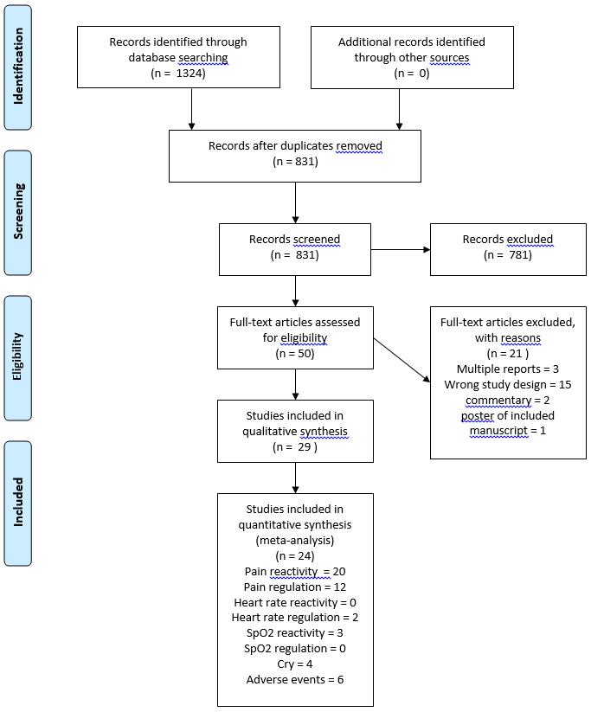

Supplementary figure 1. PRISMA flow diagram

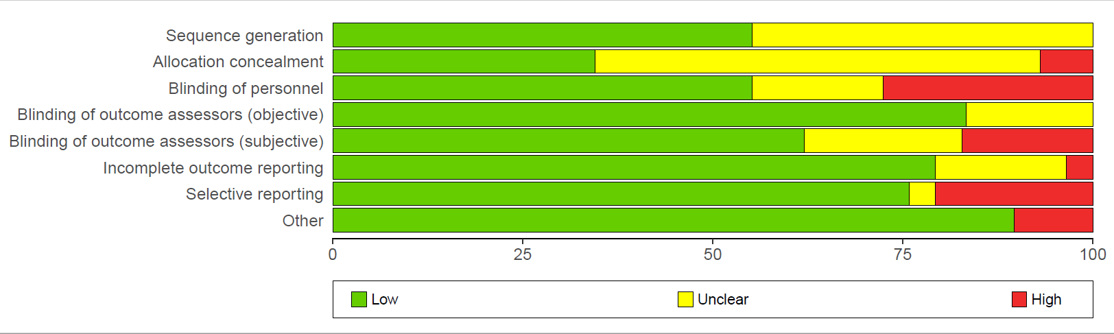

Supplementary figure 2. Risk of Bias of included studies

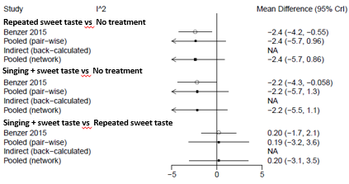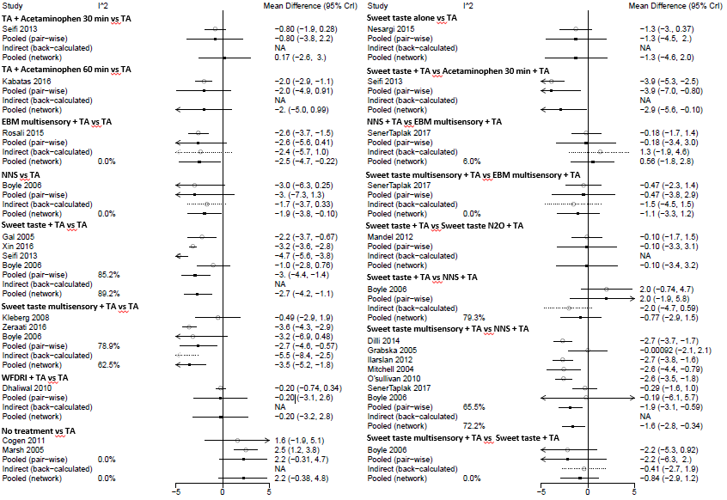

Supplementary figure 3. Pain reactivity all pairwise comparisons with direct and indirect evidence including all trials.

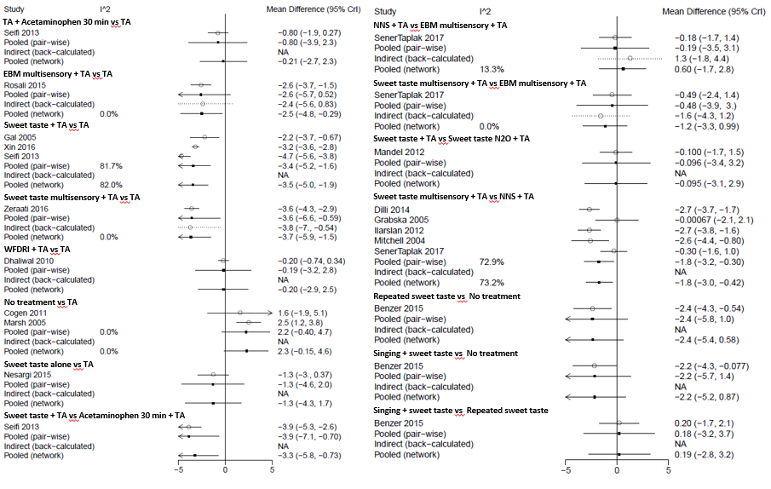

Supplementary figure 4. Pain reactivity all pairwise comparisons with direct and indirect evidence excluding Boyle and studies with imputed means.

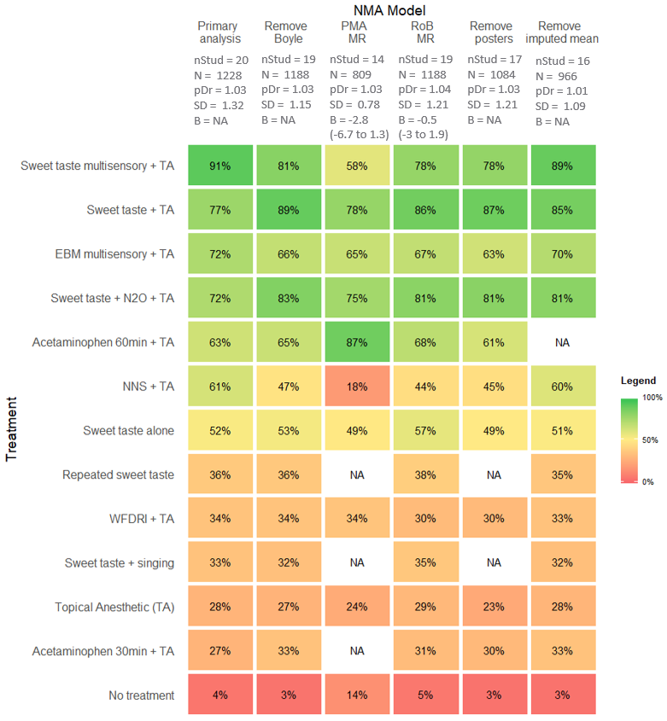

Supplementary figure 5. PIPP reactivity sensitivity analyses based on SUCRA. Higher scores indicating higher ranking treatment, NA indicates no information for a treatment. nStud = number of studies; N = total sample size; pDr = Ratio of residual deviance to unconstrained data points, SD = between-trial heterogeneity in units on the PIPP; MR = meta-regression.

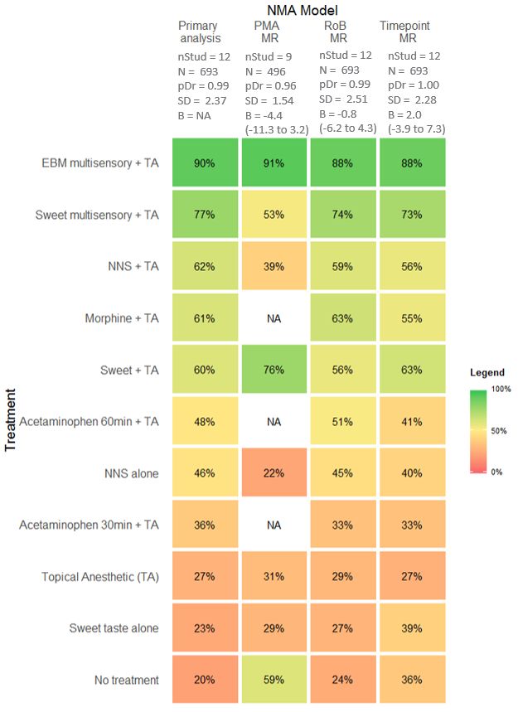

Supplementary figure 6. PIPP regulation sensitivity analyses based on SUCRA. Higher scores indicating higher ranking treatment, NA indicates no information for a treatment. nStud = number of studies; N = total sample size; pDr = Ratio of residual deviance to unconstrained data points, SD = between-trial heterogeneity in units on the PIPP; MR = meta-regression.

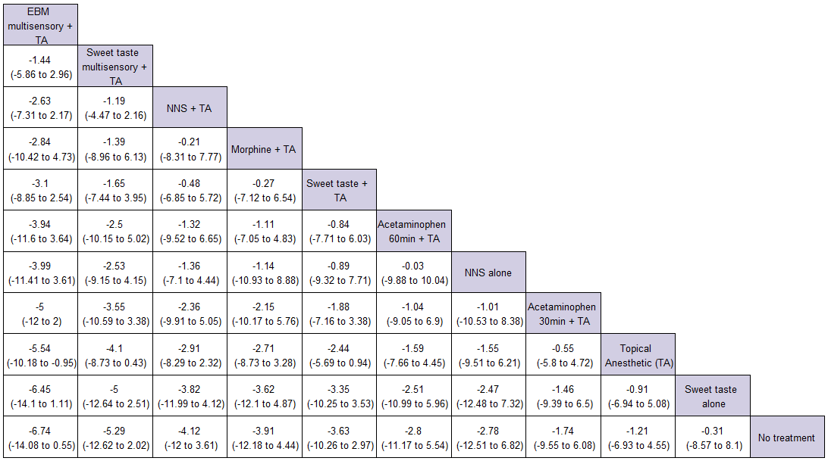

Supplementary figure 7 Pain regulation league table of NMA estimates. Treatments are reported in order of SUCRA ranking. Comparisons should be read left to right with mean differences of less than 0 indicating the treatment in the column is favoured over the treatment in the row. TA = topical anesthetic; NNS = non-nutritive sucking

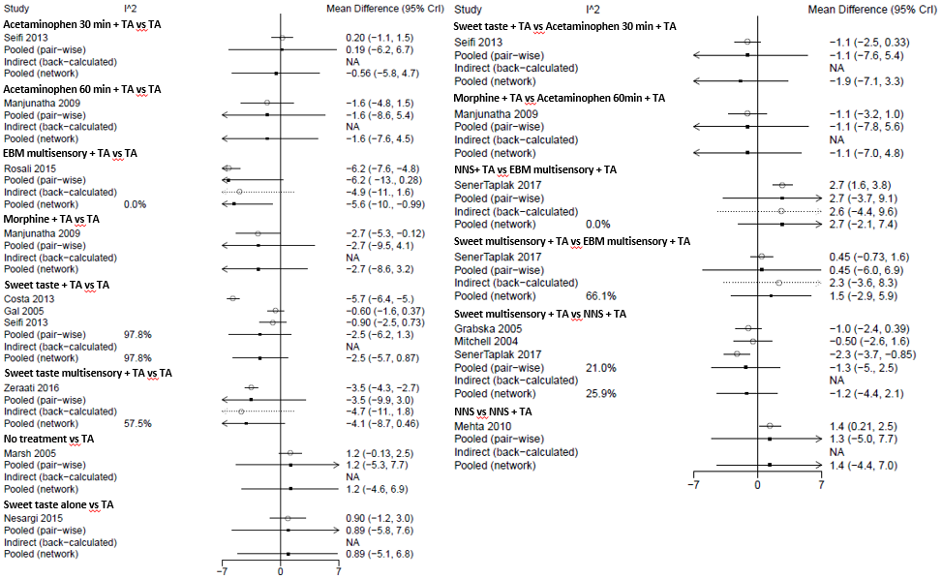

Supplementary figure 8. Pain regulation all pairwise comparisons with direct and indirect evidence.

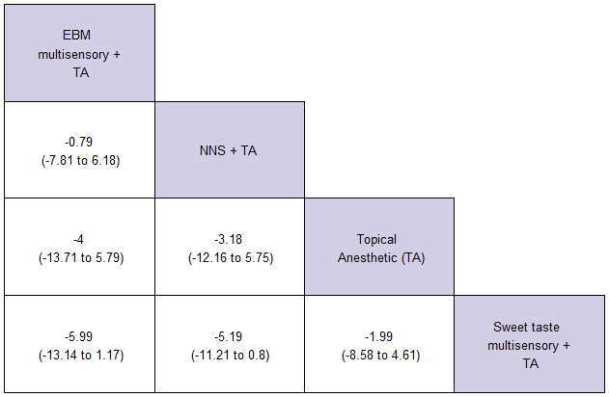

Supplementary figure 9. Heart rate regulation league table of NMA estimates. Treatments are reported in order of SUCRA ranking. Comparisons should be read left to right with mean differences of less than 0 indicating the treatment in the column is favoured over the treatment in the row. TA = topical anesthetic; NNS = non-nutritive sucking

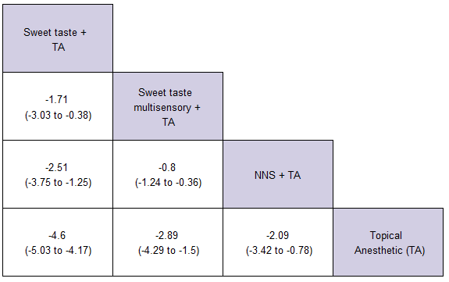

Supplementary figure 10. SpO2 reactivity league table of NMA estimates. Treatments are reported in order of SUCRA ranking. Comparisons should be read left to right with mean differences of less than 0 indicating the treatment in the column is favoured over the treatment in the row. TA = topical anesthetic; NNS = non-nutritive sucking

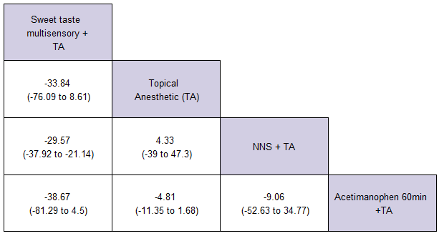

Supplementary figure 11. Cry time league table of NMA estimates. Treatments are reported in order of SUCRA ranking. Comparisons should be read left to right with mean differences of less than 0 indicating the treatment in the column is favoured over the treatment in the row.

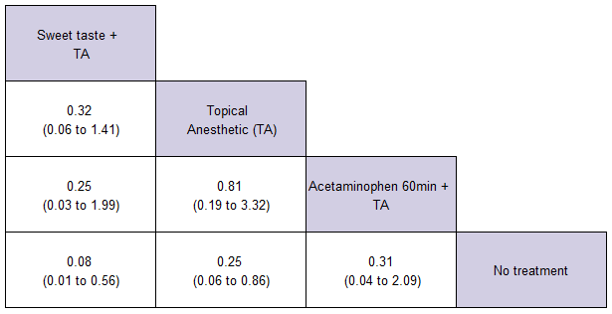

Supplementary figure 12.Adverse event reactivity league table of NMA estimates. Treatments are reported in order of SUCRA ranking. Comparisons should be read left to right with odds ratios of less than 0 indicating the treatment in the column is favoured over the treatment in the row.

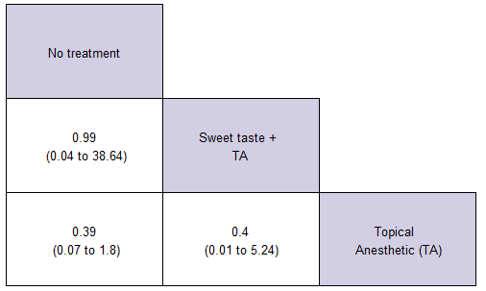

Supplementary figure 13. .Adverse event regulation league table of NMA estimates. Treatments are reported in order of SUCRA ranking. Comparisons should be read left to right with odds ratios of less than 0 indicating the treatment in the column is favoured over the treatment in the row.